

Spring Term 2026 Menu
Weeks Commencing: 12th January, 9th February & 16th March

Week 2 | Monday | Tuesday | Wednesday | Thursday | Friday
Main Option | Beef Meatball Sub with Croquettes  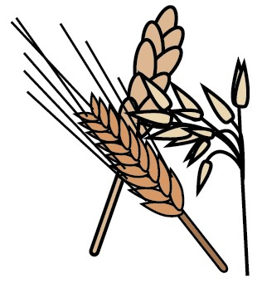 | Barbecue Chicken  Pizza with Smiley  Potatoes | Easy Pork Mince  Souvlaki on Wraps or  Pitas | Pork Chipolata in a  Hot Dog bun with  Diced Potatoes &  Ketchup | Fish Fingers with  Chips and Ketchup  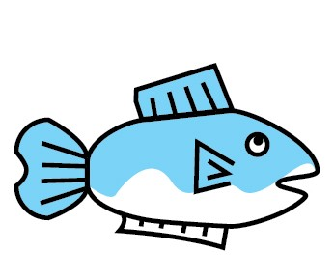
Meat Free Option | Vegan Meatball Sub with Croquettes | Cheese Pizza with Smiley Potatoes | Cheese & Tomato  Pasta with Herby Bread | Quorn Hot Dogs with  Diced Potatoes & Ketchup | Fishless Fingers with Chips and Ketchup
Alternative Option | Turkey or Cheese Sandwich  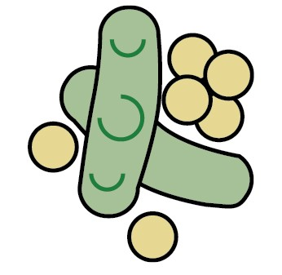  or  Jacket Potato with a Choice of  Filling | Crumpets with a  Choice of Topping  or  Jacket Potato with a Choice of  Filling | Sweetcorn & Tuna or Cheese Roll    or  Jacket Potato with a Choice of  Filling | Egg & Cress or  Cheese Sandwich    or  Jacket Potato with a Choice of  Filling | Ham or Cheese Roll  or  Jacket Potato with a Choice of  Filling
Vegetables | Corn on the Cob | Salad | Pickled Vegetables | Salad or Spaghetti  Hoops | Baked Beans
Dessert | Pudding of the Day  Salad Bar & Fresh Fruit or Yoghurt Available Daily
All meals are prepared fresh on the day using local fresh products when possible

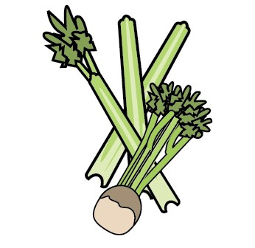
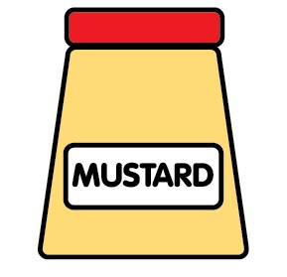
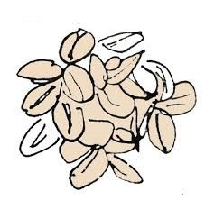
No nuts are present in any of our meals or in the preparation area, however some meals contain the following (a full list of allergens can be requested):

Celery Wheat Milk/Dairy Eggs Fish Sulphites Mustard Soya Barley Oats Sesame

